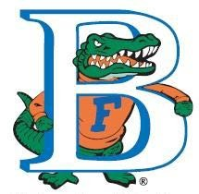

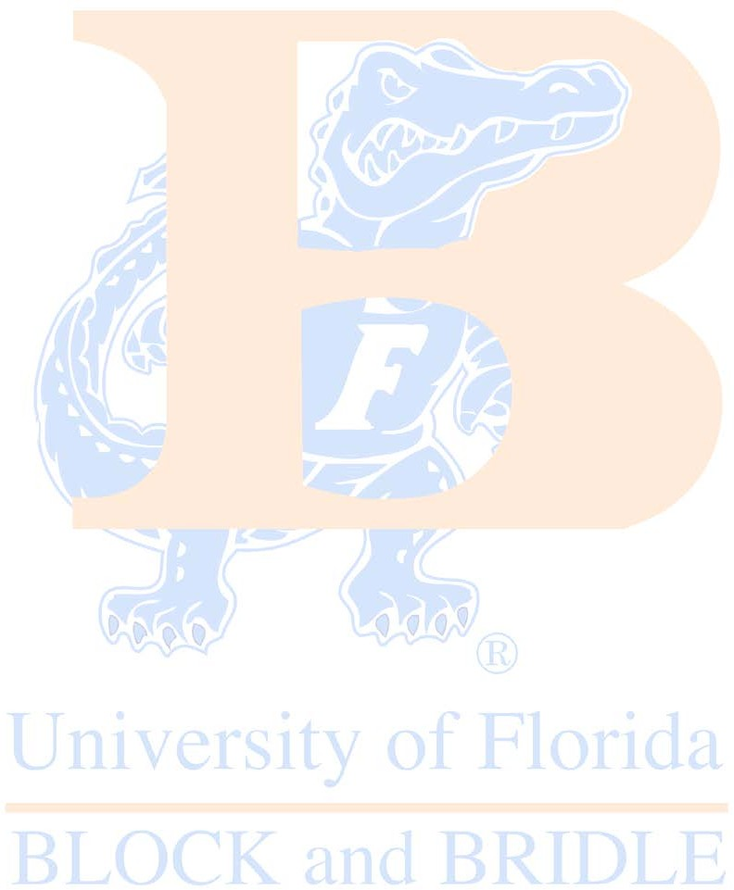
Dear UF Supporter,

Block & Bridle Club
UNIVERSITY of FLORIDA
121 Animal Science Bldg.
P.O. Box 110910 Gainesville, FL 32611

On March 21-22, 2020 the University of Florida’s Block and Bridle Club will be hosting the 15th Annual Ropin’ in The Swamp which is our annual team roping event and the largest fundraiser of the year. This event provides club members with opportunities to build relationships with fellow members and alumni while planning and hosting this huge event. Last year there were over 600 participants. Block and Bridle is a nationally recognized service and career development organization comprised of undergraduate students who enjoy working with and learning about the livestock industry and agriculture. Club members perform community service, educational events, career development projects, and working with the youth of Florida who have an interest in agriculture.

On behalf of our club, I invite you to support the Block and Bridle Club and its endeavors with the University of Florida’s Block and Bridle’s Ropin’ in the swamp event. This is a great opportunity to support UF students that are interested in the agricultural way of life.
Sponsorship details can be found attached to this letter. Sponsorship will help defer the cost of hosting Ropin’ in the Swamp as well as raise money to assist the club in its many educational and service projects.

Thank you in advance for helping us make the 15th Annual Ropin’ in The Swamp a true success. Your support and generosity are greatly appreciated and crucial to the success of the event.

Sincerely,

Ally Bennett and Lydia Hays

Ally Bennett and Lydia Hays
Block and Bridle Ropin’ in The Swamp Co-Chairmen

15 th Annual Ropin’ in the Swamp
Sponsorship Form

Business Name: Contact Person: Address: _
Phone: Email Address:
Please indicate which type of sponsorship you would like to provide Block and Bridle for Roping in the Swamp 2020:
Sponsorship Categories and Awards:
$2500 Saddle sponsor for High-Point Header (Logo on check and T-Shirts)
$2500 Saddle sponsor for High-Point Heeler (Logo on check and T-Shirts)
$2000 Sign Sponsor displayed in the Horse Teaching Unit Arena for one year
$500 Food sponsor
$200 Single banner sponsorship (3X6)
$100 Logo included on a General sponsorship banner
$100 Vendor space
General Donation of any amount (Recognized throughout the day)
Silent Auction Item(s)
Please make all checks payable to “University of Florida Block and Bridle” Advertisements and Sponsorship requests are due March 4, 2020. Please send to: Block and Bridle
Attn: Ally Bennett and Lydia Hays
UF Animal Science Department
P.O. Box 110910 Gainesville, FL 32611

For more information contact:
Ally Bennett 904-487-4632
Lydia Hays 407-361-5451
lydiahays@ufl.edu
alexandrabennett@ufl.edu

